Deadlock in OS
Deadlock is a situation where-
The execution of two or more processes is blocked because each process holds some resource and waits for another resource held by some other process.
- Deadlock is a situation in an operating system where two or more processes are blocked forever because each is waiting for a resource held by another process.

- Deadlock occurs when a group of processes are unable to proceed because they are waiting for resources in a circular waiting condition.

- Deadlock is a state in which processes cannot continue execution because required resources are not released by other waiting processes.
- Deadlock is a situation in an operating system where two or more processes are permanently blocked because each is waiting for a resource held by another.
👉 Example: Process A holds Printer and waits for Scanner, while Process B holds Scanner and waits for Printer.
- Deadlock occurs when processes enter a circular waiting condition, where each process depends on another in a loop.
- It happens when resources are not preemptable, meaning the OS cannot forcibly take resources away from a process.
- Deadlock leads to system halt or infinite waiting, reducing system efficiency and performance.
- Analogy: Two people are trying to pass each other in a narrow bridge—each refuses to step back, so both remain stuck forever.
Example-

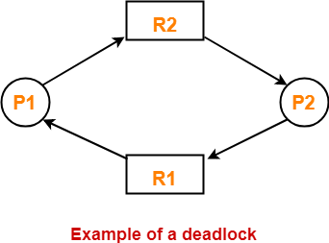
Here
- Process P1 holds resource R1 and waits for resource R2 which is held by process P2.
- Process P2 holds resource R2 and waits for resource R1 which is held by process P1.
- None of the two processes can complete and release their resource.
- Thus, both the processes keep waiting infinitely.

Conditions For Deadlock-

There are following 4 necessary conditions for the occurrence of deadlock-
- Mutual Exclusion
- Hold and Wait
- No preemption
- Circular wait

1. Mutual Exclusion-
By this condition,
- There must exist at least one resource in the system which can be used by only one process at a time.
- If there exists no such resource, then deadlock will never occur.
- Printer is an example of a resource that can be used by only one process at a time.

2. Hold and Wait-
By this condition,
- There must exist a process which holds some resource and waits for another resource held by some other process.

3. No Preemption-
By this condition,
- Once the resource has been allocated to the process, it can not be preempted.
- It means resource can not be snatched forcefully from one process and given to the other process.
- The process must release the resource voluntarily by itself.

4. Circular Wait:
By this condition,
- All the processes must wait for the resource in a cyclic manner where the last process waits for the resource held by the first process.
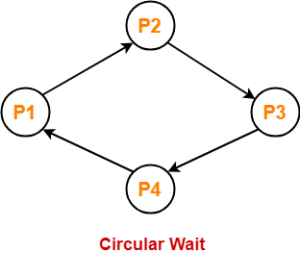

Here,
- Process P1 waits for a resource held by process P2.
- Process P2 waits for a resource held by process P3.
- Process P3 waits for a resource held by process P4.
- Process P4 waits for a resource held by process P1.

Important Note-
- All these 4 conditions must hold simultaneously for the occurrence of deadlock.
- If any of these conditions fail, then the system can be ensured deadlock free.

What are resources in deadlock?
In Operating System, resources are the hardware or software components that processes need to execute their tasks. A deadlock happens when processes compete for these resources and get stuck waiting forever, because each process is holding some resource and waiting for another one.
👉 In simple terms:
Resources are the “things” processes need to complete their work (like printer, memory, CPU time).

🔷 Types of Resources in Deadlock (with examples)
Resources in OS are generally classified into four main types:

🔹 1. Reusable Resources ♻️

🔸 Meaning:
Resources that can be used by one process at a time and then reused by others.

🔸 Examples:
- Printer 🖨️
- Scanner 📠
- CPU
- Memory (RAM)

🔸 In Deadlock:
A process holds one reusable resource and waits for another.
👉 Example:
- Process A holds Printer
- Process B holds Scanner
- A waits for Scanner, B waits for Printer → Deadlock
📚 Analogy:
Two people sharing one pen and one notebook, each waiting for the other item.

🔹 2. Consumable Resources 🔥

🔸 Meaning:
Resources that are produced and consumed, and once used they disappear.

🔸 Examples:
- Interrupt signals
- Messages in message queues
- Data packets

🔸 In Deadlock:
A process waits for a resource that is not yet produced.
👉 Example:
- Process A waits for a message from Process B
- Process B is waiting for CPU time
→ Both are stuck
📚 Analogy:
Waiting for someone to send you a text message before you can reply.

🔹 3. Physical Resources 🖥️

🔸 Meaning:
Hardware components required for processing.

🔸 Examples:
- CPU
- Hard disk
- Keyboard
- Printer

🔸 In Deadlock:
Multiple processes compete for limited hardware.
👉 Example:
Two processes waiting for the same printer.
📚 Analogy:
Two students waiting for the only calculator in class.

🔹 4. Logical (Virtual) Resources 💾

🔸 Meaning:
Software or system-managed resources.

🔸 Examples:
- Files
- Semaphores
- Locks
- Database records

🔸 In Deadlock:
Processes lock files or data and wait for others to release locks.
👉 Example:
- Process A locks File 1
- Process B locks File 2
- A waits for File 2, B waits for File 1 → Deadlock
📚 Analogy:
Two people locking two different rooms and waiting for each other’s key.

📊 Summary Table
Type | Nature | Examples | Deadlock Scenario
Reusable | Can be reused | Printer, CPU | Competing for devices
Consumable | Used once | Messages, signals | Waiting for production
Physical | Hardware | Disk, keyboard | Device contention
Logical | Software | Files, locks | File/resource locking

🎯 Final Understanding
👉 Resources in deadlock are anything needed by a process to complete execution.
👉 Deadlock occurs when processes hold resources and wait endlessly for others, forming a circular dependency.

Preemptable and Non-Preemptable Resources in Deadlock (OS)
In Operating Systems, resources are classified based on whether the OS can forcefully take them away from a process or not. This is very important in understanding deadlock.

🔹 1. Preemptable Resources ♻️

🔸 Meaning:
Preemptable resources are those resources that the operating system can take back (preempt) from a process and give to another process without causing damage or inconsistency.
👉 In simple terms:
The OS can “snatch and reassign” these resources safely.

🔸 Key Idea:
- Can be temporarily taken away
- No harm to process or system state
- Helps in avoiding deadlock

🔸 Examples (3):
- CPU (Processor time) 🧠
  - OS can interrupt a running process and give CPU to another (context switching)
- Main Memory (RAM pages) 💾
  - Pages can be swapped out to disk and given to other processes
- Cache memory blocks ⚡
  - Cache lines can be replaced and reassigned to other processes

📚 Analogy:
A teacher takes a pen from one student temporarily and gives it to another student.

🔹 2. Non-Preemptable Resources 🚫

🔸 Meaning:
Non-preemptable resources are those resources that cannot be taken away from a process once assigned, until the process voluntarily releases them.
👉 In simple terms:
The OS must wait until the process finishes using them.

🔸 Key Idea:
- Cannot be forcibly removed
- Must be released by the process
- Major cause of deadlock

🔸 Examples (3):
- Printer 🖨️
  - Once a process is printing, OS cannot stop and reassign it safely
- File locks 📂
  - A process locks a file; others must wait until it unlocks
- Scanner or I/O device 📠
  - Cannot interrupt scanning in between without corruption

📚 Analogy:
A student using a single notebook cannot be forced to give it to another student in the middle of writing.

📊 Quick Comparison
Feature | Preemptable | Non-Preemptable
Can OS take it back? | Yes | No
Risk of inconsistency | Low | High
Deadlock impact | Less likely | More likely
Examples | CPU, RAM | Printer, files
Resource Allocation Graph-
- Resource Allocation Graph (RAG) is a graph that represents the state of a system pictorially.
- It gives complete information about the state of a system such as-
- How many processes exist in the system?
- How many instances of each resource type exist?
- How many instances of each resource type are allocated?
- How many instances of each resource type are still available?
- How many instances of each resource type are held by each process?
- How many instances of each resource type does each process need for execution?
Components Of RAG-
There are two major components of a Resource Allocation Graph-
- Vertices
- Edges

Vertices-
There are following types of vertices in a Resource Allocation Graph-

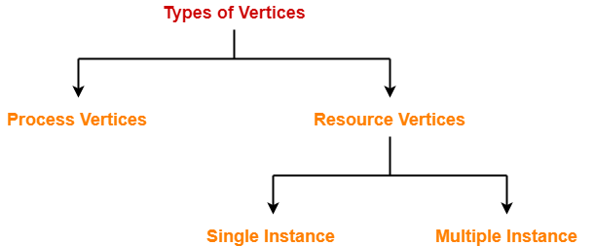

- Process Vertices
- Resource Vertices

Process Vertices-
- Process vertices represent the processes.
- They are drawn as a circle by mentioning the name of process inside the circle.

Resource Vertices-
- Resource vertices represent the resources.
- Depending on the number of instances that exists in the system, resource vertices may be single instance or multiple instance.
- They are drawn as a rectangle by mentioning the dots inside the rectangle.
- The number of dots inside the rectangle indicates the number of instances of that resource existing in the system.

Edges-
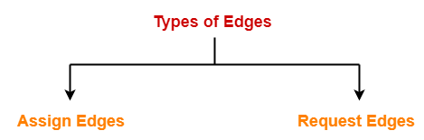
- Assign Edges
- Request Edges
Assign Edges-
- Assign edges represent the assignment of resources to the processes.
- They are drawn as an arrow where the head of the arrow points to the process and tail of the process points to the instance of the resource.
Request Edges-
- Request edges represent the waiting state of processes for the resources.
- They are drawn as an arrow where the head of the arrow points to the instance of the resource and tail of the process points to the process.
- If a process requires ‘n’ instances of a resource type, then ‘n’ assign edges will be drawn.
Example Of RAG-
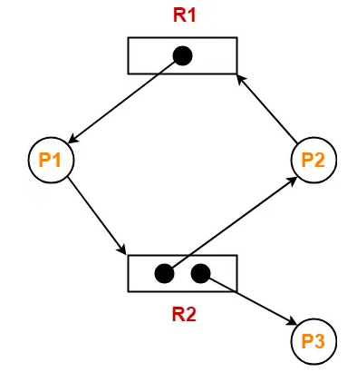
The above diagram represents a Resource Allocation Graph-

It gives the following information-
- There exist three processes in the system namely P1, P2 and P3.
- There exist two resources in the system namely R1 and R2.
- There exists a single instance of resource R1 and two instances of resource R2.
- Process P1 holds one instance of resource R1 and is waiting for an instance of resource R2.
- Process P2 holds one instance of resource R2 and is waiting for an instance of resource R1.
- Process P3 holds one instance of resource R2 and is not waiting for anything.

Deadlock Detection-
- Using Resource Allocation Graph, it can be easily detected whether system is in a Deadlock state or not.
- The rules are-
Rule-01:
- In a Resource Allocation Graph where all the resources are single instance,
- If a cycle is being formed, then system is in a deadlock state.
- If no cycle is being formed, then system is not in a deadlock state.
Rule-02:
- In a Resource Allocation Graph where all the resources are NOT single instance,
- If a cycle is being formed, then system may be in a deadlock state.
- Banker’s Algorithm is applied to confirm whether system is in a deadlock state or not.
- If no cycle is being formed, then system is not in a deadlock state.
- Presence of a cycle is a necessary but not a sufficient condition for the occurrence of deadlock.

PRACTICE PROBLEMS BASED ON DETECTING DEADLOCK USING RAG-

Problem-01:
Consider the resource allocation graph in the figure-
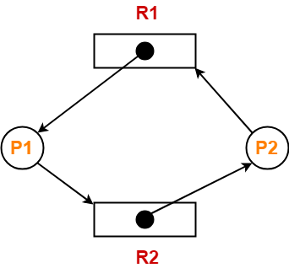
Find if the system is in a deadlock state otherwise find a safe sequence.
Solution-
Method-01:
- The given resource allocation graph is single instance with a cycle contained in it.
- Thus, the system is definitely in a deadlock state.

Method-02:
Using the given resource allocation graph, we have-

 | Allocation |  | Need
 | R1 | R2 | R1 | R2
Process P1 | 1 | 0 | 0 | 1
Process P2 | 0 | 1 | 1 | 0
Available = [ R1 R2 ] = [ 0 0 ]
Now,
- There are no instances available currently and both the processes require a resource to execute.
- Therefore, none of the process can be executed and both keeps waiting infinitely.
- Thus, the system is in a deadlock state.

Problem-02:
Consider the resource allocation graph in the figure-
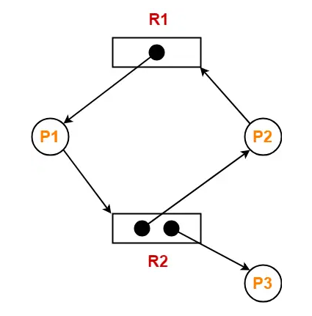
Find if the system is in a deadlock state otherwise find a safe sequence.
Solution-
- The given resource allocation graph is multi instance with a cycle contained in it.
- So, the system may or may not be in a deadlock state.

Using the given resource allocation graph, we have-

 | Allocation |  | Need
 | R1 | R2 | R1 | R2
Process P1 | 1 | 0 | 0 | 1
Process P2 | 0 | 1 | 1 | 0
Process P3 | 0 | 1 | 0 | 0
Available = [ R1 R2 ] = [ 0 0 ]
Step-01:
- Since process P3 does not need any resource, so it executes.
- After execution, process P3 release its resources.
Then,
Available
= [ 0 0 ] + [ 0 1 ]
= [ 0 1 ]
Step-02:
- With the instances available currently, only the requirement of the process P1 can be satisfied.
- So, process P1 is allocated the requested resources.
- It completes its execution and then free up the instances of resources held by it.
Then-
Available
= [ 0 1 ] + [ 1 0 ]
= [ 1 1 ]
Step-03:
- With the instances available currently, the requirement of the process P2 can be satisfied.
- So, process P2 is allocated the requested resources.
- It completes its execution and then free up the instances of resources held by it.
Then-
Available
= [ 1 1 ] + [ 0 1 ]
= [ 1 2 ]
Thus,
- There exists a safe sequence P3, P1, P2 in which all the processes can be executed.
- So, the system is in a safe state.

Problem-03:
Consider the resource allocation graph in the figure-
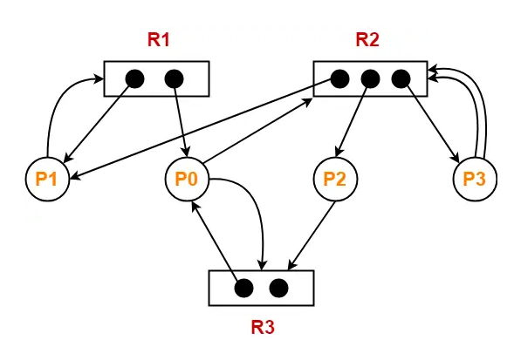
Find if the system is in a deadlock state otherwise find a safe sequence.
Solution-
- The given resource allocation graph is multi instance with a cycle contained in it.
- So, the system may or may not be in a deadlock state.

Using the given resource allocation graph, we have-
 | Allocation |  |  | Need
 | R1 | R2 | R3 | R1 | R2 | R3
Process P0 | 1 | 0 | 1 | 0 | 1 | 1
Process P1 | 1 | 1 | 0 | 1 | 0 | 0
Process P2 | 0 | 1 | 0 | 0 | 0 | 1
Process P3 | 0 | 1 | 0 | 0 | 2 | 0
Available = [ R1 R2 R3 ] = [ 0 0 1 ]
Step-01:
- With the instances available currently, only the requirement of the process P2 can be satisfied.
- So, process P2 is allocated the requested resources.
- It completes its execution and then free up the instances of resources held by it.
Then-
Available
= [ 0 0 1 ] + [ 0 1 0 ]
= [ 0 1 1 ]
Step-02:
- With the instances available currently, only the requirement of the process P0 can be satisfied.
- So, process P0 is allocated the requested resources.
- It completes its execution and then free up the instances of resources held by it.
Then-
Available
= [ 0 1 1 ] + [ 1 0 1 ]
= [ 1 1 2 ]
Step-03:
- With the instances available currently, only the requirement of the process P1 can be satisfied.
- So, process P1 is allocated the requested resources.
- It completes its execution and then free up the instances of resources held by it.
Then-
Available
= [ 1 1 2 ] + [ 1 1 0 ]
= [ 2 2 2 ]
Step-04:

- With the instances available currently, the requirement of the process P3 can be satisfied.
- So, process P3 is allocated the requested resources.
- It completes its execution and then free up the instances of resources held by it.
Then-
Available
= [ 2 2 2 ] + [ 0 1 0 ]
= [ 2 3 2 ]
Thus,
- There exists a safe sequence P2, P0, P1, P3 in which all the processes can be executed.
- So, the system is in a safe state.

Deadlock Handling-
The various strategies for handling deadlock are-



- Deadlock Prevention
- Deadlock Avoidance
- Deadlock Detection and Recovery
- Deadlock Ignorance

Deadlock Prevention-

- This strategy involves designing a system that violates one of the four necessary conditions required for the occurrence of deadlock.
- This ensures that the system remains free from the deadlock.
The various conditions of deadlock occurrence may be violated as-
1. Mutual Exclusion-
- To violate this condition, all the system resources must be such that they can be used in a shareable mode.
- In a system, there are always some resources which are mutually exclusive by nature.
- So, this condition can not be violated.
2. Hold and Wait-
This condition can be violated in the following ways-
Approach-01:
In this approach,
- A process has to first request for all the resources it requires for execution.
- Once it has acquired all the resources, only then it can start its execution.
- This approach ensures that the process does not hold some resources and wait for other resources.
Drawbacks-
The drawbacks of this approach are-
- It is less efficient.
- It is not implementable since it is not possible to predict in advance which resources will be required during execution.

Approach-02:
In this approach,
- A process is allowed to acquire the resources it desires at the current moment.
- After acquiring the resources, it start its execution.
- Now before making any new request, it has to compulsorily release all the resources that it holds currently.
- This approach is efficient and implementable.

Approach-03:
In this approach,
- A timer is set after the process acquires any resource.
- After the timer expires, a process has to compulsorily release the resource.

3. No Preemption-
- This condition can by violated by forceful preemption.
- Consider a process is holding some resources and request other resources that can not be immediately allocated to it.
- Then, by forcefully preempting the currently held resources, the condition can be violated.

A process is allowed to forcefully preempt the resources possessed by some other process only if-
- It is a high priority process or a system process.
- The victim process is in the waiting state.

4. Circular Wait-
- This condition can be violated by not allowing the processes to wait for resources in a cyclic manner.
- To violate this condition, the following approach is followed-
Approach-
- A natural number is assigned to every resource.
- Each process is allowed to request for the resources either in only increasing or only decreasing order of the resource number.
- In case increasing order is followed, if a process requires a lesser number resource, then it must release all the resources having larger number and vice versa.
- This approach is the most practical approach and implementable.
- However, this approach may cause starvation but will never lead to deadlock.

Deadlock Avoidance-
- This strategy involves maintaining a set of data using which a decision is made whether to entertain the new request or not.
- If entertaining the new request causes the system to move in an unsafe state, then it is discarded.
- This strategy requires that every process declares its maximum requirement of each resource type in the beginning.
- The main challenge with this approach is predicting the requirement of the processes before execution.
- Banker’s Algorithm is an example of a deadlock avoidance strategy.

Deadlock Detection and Recovery-
- This strategy involves waiting until a deadlock occurs.
- After deadlock occurs, the system state is recovered.
- The main challenge with this approach is detecting the deadlock.
Deadlock Ignorance-
- This strategy involves ignoring the concept of deadlock and assuming as if it does not exist.
- This strategy helps to avoid the extra overhead of handling deadlock.
- Windows and Linux use this strategy and it is the most widely used method.
- It is also called as Ostrich approach.

Deadlock Ignorance: Ostrich approach.
- The Ostrich Algorithm in Operating Systems is a strategy where the system intentionally ignores problems like deadlocks instead of trying to prevent or solve them.
- It is called the “ostrich” algorithm because it is based on the popular analogy of an ostrich hiding its head in the sand to avoid danger.
- In this approach, the operating system assumes that deadlocks occur so rarely that the cost of detecting and recovering from them is greater than the damage caused by the occasional problem.
- For example, in a computer system, two programs may each wait forever for resources held by the other, causing a deadlock, but the operating system may simply ignore it because such situations are uncommon.
- A real-life analogy is a city traffic department ignoring very rare traffic jams on a small road because installing expensive traffic-control systems would cost more than the occasional inconvenience.
- Similarly, some operating systems like early versions of UNIX and Linux often use this approach for certain resource-management situations, since deadlocks are infrequent and users can usually restart the affected program.
- The main advantage of the ostrich algorithm is that it saves system resources and keeps the operating system simple and efficient because no extra overhead is needed for deadlock prevention or detection.
- However, its disadvantage is that if a deadlock actually occurs, the affected processes may freeze indefinitely, forcing the user or administrator to manually terminate and restart the programs or even reboot the system.

Deadlock Recovery in Operating System
A deadlock occurs when two or more processes are waiting for resources held by each other, and none of them can proceed.

Simple Definition
Deadlock recovery is the process used by an operating system to break a deadlock and make the system work normally again.

Real-Life Analogy of Deadlock
Imagine two cars stuck on a narrow bridge:
- Car A waits for Car B to move.
- Car B waits for Car A to move.
- Neither can move forward.
To solve this:
- One car may reverse.
- One driver may leave the bridge.
- Police may remove one vehicle.
This is similar to deadlock recovery in OS.

Example of Deadlock in OS
Suppose:
- Process P1 holds Printer and waits for Scanner.
- Process P2 holds Scanner and waits for Printer.
Both wait forever → Deadlock occurs.
The operating system must recover from this situation.

Deadlock Recovery Techniques
There are mainly two recovery techniques:
- Process Termination
- Resource Preemption

1. Process Termination
The operating system stops one or more processes to break the deadlock.

Types of Process Termination

(a) Abort All Deadlocked Processes
- OS kills all deadlocked processes.
- All resources are released immediately.

Example
- P1 and P2 are deadlocked.
- OS terminates both processes.

Advantages
- Simple and fast.

Disadvantages
- Loss of all process work.
- Data may be lost.

Analogy
Two students fight over one chair. Teacher sends both students out of the classroom.

(b) Abort One Process at a Time
- OS terminates processes one by one until deadlock disappears.

Example
- OS kills P2 only.
- P1 gets needed resource and continues.

Advantages
- Less work loss.

Disadvantages
- Takes more time to decide which process to terminate.

Factors Considered Before Termination
OS may check:
- Process priority
- Process execution time
- Number of resources used
- Importance of process
- Remaining completion time

Analogy
Traffic police ask only one car to reverse instead of removing all cars.

2. Resource Preemption
In this method, the OS temporarily takes resources away from some processes and gives them to others.

Steps in Resource Preemption

Step 1: Select Victim
Choose a process whose resource will be taken away.

Step 2: Rollback
Save process state and return it to a safe state.

Step 3: Restart
Restart the process later after resources become available.

Example
- P1 holds Printer.
- P2 holds Scanner.
- OS takes Scanner from P2 and gives it to P1.
- P1 finishes and releases Printer.
- Then P2 continues.

Advantages
- Avoids killing processes completely.
- Saves some work.

Disadvantages
- Complex to implement.
- Some resources cannot be taken back easily.

Analogy
A teacher takes a calculator from one student temporarily and gives it to another student to finish urgent work.

Rollback Concept
Rollback means returning a process to an earlier safe state.

Example
If a game crashes:
- It reloads from the last saved checkpoint.
Similarly, OS restores a process from a saved state.

Starvation Problem in Recovery
Sometimes the same process is repeatedly selected as victim.
That process may never complete.
This situation is called starvation.

Comparison of Recovery Techniques
Technique | Meaning | Advantage | Disadvantage
Process Termination | Kill processes | Simple | Loss of work
Resource Preemption | Take resources back | Saves processes | Complex

Key Points About Deadlock Recovery
- Recovery starts after deadlock is detected.
- Main goal is to free resources.
- OS may terminate processes or preempt resources.
- Process termination is easier.
- Resource preemption is more efficient but difficult.
- Rollback helps restore process state.
- Victim selection is important.
- Starvation may occur during recovery.
- Recovery improves system performance.
- Deadlock recovery is widely used in multitasking systems.

DEADLOCK AVOIDANCE ALGORITHM : Banker's Algorithm

Definition
Banker’s Algorithm is a deadlock avoidance algorithm used in an operating system to allocate resources safely among multiple processes.
It is called the Banker’s Algorithm because it works like a banker in a bank:
- A banker gives loans only if the bank can still safely satisfy all customers later.
- Similarly, the OS allocates resources only if the system remains in a safe state after allocation.

Significance of Banker’s Algorithm

1. Prevents Deadlock
The main purpose is to avoid deadlock before it occurs.

Analogy
Imagine a hotel with only 10 rooms.
- If the manager gives rooms carelessly, some guests may never get rooms.
- So the manager checks future availability before confirming bookings.
Similarly, Banker’s Algorithm checks future resource availability before allocation.

2. Maintains Safe State
It ensures the system always remains in a safe sequence where every process can complete successfully.

3. Efficient Resource Utilization
Resources are allocated carefully without causing system halt.

4. Predicts Future Needs
The algorithm considers:
- current allocation
- maximum future demand
- available resources
before granting requests.

5. Used in Multiprogramming Systems
Useful in systems where multiple processes compete for limited resources.

Important Terminologies Used in Banker’s Algorithm

1. Available
Number of free resources currently available in the system.

Example
If total printers = 5 and allocated = 3
then available printers = 2

2. Maximum (Max)
Maximum number of resources a process may need to complete execution.

Example
Process P1 may need at most 7 tape drives.

3. Allocation
Resources currently allocated to a process.

Example
P1 already holds 3 resources.

4. Need
Remaining resources required by a process.

Formula
Need=Max−Allocation

Example
If:
- Max = 7
- Allocation = 3
Then:
- Need = 4

5. Safe State
A state in which all processes can finish execution in some order without deadlock.

6. Unsafe State
A condition where deadlock may occur in future.
Unsafe state does not always mean deadlock immediately, but the possibility exists.

7. Safe Sequence
An order in which processes can execute completely without causing deadlock.

Example
P1 → P3 → P2 → P4

Steps of Banker’s Algorithm

Step 1: Calculate Need Matrix
Use:
Need[i][j]=Max[i][j]−Allocation[i][j]

Step 2: Find a Process Whose Need ≤ Available
Check all processes.
If a process can get required resources:
- execute it
- release its allocated resources back

Step 3: Add Released Resources to Available

Formula
Available=Available+Allocation

Step 4: Repeat Until All Processes Finish
If all processes complete successfully:
- system is safe
Otherwise:
- unsafe state

Numerical 1: Banker’s Algorithm
Suppose there are 3 resource types A, B and C.

Available Resources
A | B | C
3 | 3 | 2

Allocation Matrix
Process | A | B | C
P0 | 0 | 1 | 0
P1 | 2 | 0 | 0
P2 | 3 | 0 | 2
P3 | 2 | 1 | 1
P4 | 0 | 0 | 2

Max Matrix
Process | A | B | C
P0 | 7 | 5 | 3
P1 | 3 | 2 | 2
P2 | 9 | 0 | 2
P3 | 2 | 2 | 2
P4 | 4 | 3 | 3

Step 1: Calculate Need Matrix
Using:
Need=Max−AllocationNeed = Max - AllocationNeed=Max−Allocation

Need Matrix
Process | A | B | C
P0 | 7 | 4 | 3
P1 | 1 | 2 | 2
P2 | 6 | 0 | 0
P3 | 0 | 1 | 1
P4 | 4 | 3 | 1

Step 2: Find Safe Sequence
Initial Available = (3,3,2)

Process P1
Need(P1) = (1,2,2)
Since:
(1,2,2) ≤ (3,3,2)
P1 executes.
New Available:
= (3,3,2) + (2,0,0)
= (5,3,2)

Process P3
Need(P3) = (0,1,1)
(0,1,1) ≤ (5,3,2)
P3 executes.
New Available:
= (5,3,2) + (2,1,1)
= (7,4,3)

Process P4
Need(P4) = (4,3,1)
(4,3,1) ≤ (7,4,3)
P4 executes.
New Available:
= (7,4,3) + (0,0,2)
= (7,4,5)

Process P0
Need(P0) = (7,4,3)
(7,4,3) ≤ (7,4,5)
P0 executes.
New Available:
= (7,4,5) + (0,1,0)
= (7,5,5)

Process P2
Need(P2) = (6,0,0)
(6,0,0) ≤ (7,5,5)
P2 executes.
Final Available:
= (7,5,5) + (3,0,2)
= (10,5,7)

Safe Sequence

P1 → P3 → P4 → P0 → P2
Hence, the system is in a safe state.

Numerical 2: Banker’s Algorithm
Suppose there are 3 resources A, B and C.

Available Resources
A | B | C
1 | 5 | 2

Allocation Matrix
Process | A | B | C
P0 | 0 | 1 | 0
P1 | 1 | 0 | 1
P2 | 1 | 3 | 5
P3 | 0 | 6 | 3

Max Matrix
Process | A | B | C
P0 | 0 | 2 | 1
P1 | 1 | 7 | 5
P2 | 2 | 3 | 5
P3 | 0 | 6 | 5

Step 1: Calculate Need Matrix
Using:
Need=Max−AllocationNeed = Max - AllocationNeed=Max−Allocation

Need Matrix
Process | A | B | C
P0 | 0 | 1 | 1
P1 | 0 | 7 | 4
P2 | 1 | 0 | 0
P3 | 0 | 0 | 2

Step 2: Check Safe Sequence
Initial Available = (1,5,2)

Process P0
Need(P0) = (0,1,1)
(0,1,1) ≤ (1,5,2)
P0 executes.
New Available:
= (1,5,2) + (0,1,0)
= (1,6,2)

Process P2
Need(P2) = (1,0,0)
(1,0,0) ≤ (1,6,2)
P2 executes.
New Available:
= (1,6,2) + (1,3,5)
= (2,9,7)

Process P3
Need(P3) = (0,0,2)
(0,0,2) ≤ (2,9,7)
P3 executes.
New Available:
= (2,9,7) + (0,6,3)
= (2,15,10)

Process P1
Need(P1) = (0,7,4)
(0,7,4) ≤ (2,15,10)
P1 executes.
Final Available:
= (2,15,10) + (1,0,1)
= (3,15,11)

Safe Sequence

P0 → P2 → P3 → P1
Hence, the system is in a safe state.
MORE NUMERICAL
https://cse.poriyaan.in/topic/deadlock-avoidance-50789/

